**DIAMOND PRICE PREDICTION USING COMPUTER VISION WITH SENSOR**

**A MINOR PROJECT SYNOPSIS**

***Submitted in partial fulfillment of th*e *requirements for the award of the degree***

***Of***

**BACHELOR OF TECHNOLOGY**

***In***

**ELECTRONICS & COMMUNICATION ENGINEERING**

***By***

**Name of the Student : ISHA Name of the Student : SOMYA ARORA**

**Enrollment No: 00415602821 Enrollment No: 03915602821**

**Section: F4 Section: F4**

**Mobile No. 9971020524 Mobile No. 9953077680**

***Guided by***

**Dr. Swati Juneja, Assistant professor, ECE Department**



**Department of Electronics & Communication Engineering**

**DR. AKHILESH DAS GUPTA INSTITUTE OF PROFESSIONAL STUDIES**

**(AFFILIATED TO GURU GOBIND SINGH INDRAPRASTHA UNIVERSITY)**

**NEW DELHI – 110053**

**August- 2024**

**Contents**

Page no. 1. Introduction 3

1. Objective and block diagram of project 3 - 5
2. Methodology and Tool Used 6-10
3. Advantages and Application of the Project 10-11
4. References 12
5. Research paper related to project 13 - 14
6. **INTRODUCTION**

Diamond price prediction involves forecasting the price of a diamond based on various characteristics, commonly referred to as the "4 Cs": Carat, Cut, Colour, and Clarity. These features significantly influence a diamond's market value, along with other factors such as market demand, economic conditions, and global trends .

The main motivation for this paper is to initiate a supervised machine learning technique for predicting diamond prices.

1. **OBJECTIVE**

The objective of a diamond price prediction project is

* to develop a reliable model that accurately estimates the price of a diamond based on its characteristics.

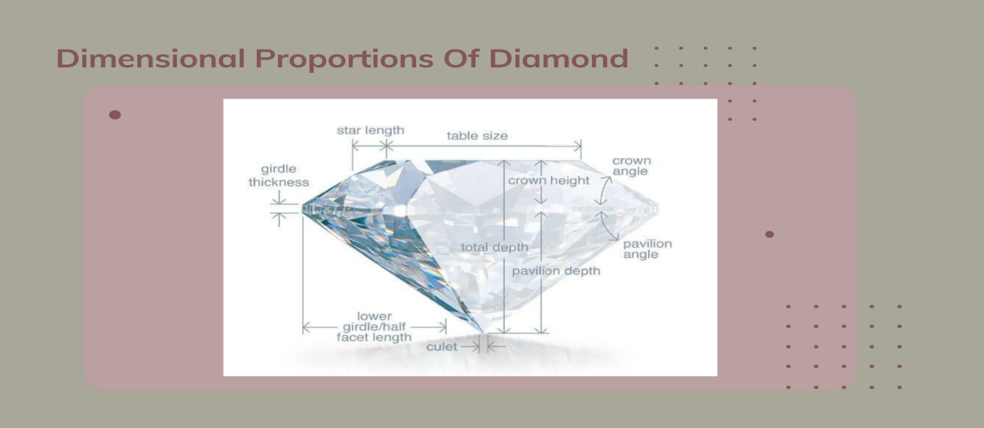

Figure 1: Dimensional proportions of diamond.

The project aims to:

* **Enhance Pricing Accuracy**: Provide precise and consistent pricing for diamonds, minimizing human error and subjectivity.
* **Support Retailers:** Help jewelers set competitive and fair prices for their diamond inventory.
* **Guide Investment Decisions:** Assist investors in evaluating the potential value and appreciation of diamonds as assets.
* **Empower Consumers:** Enable consumers to make informed purchasing decisions by providing accurate price estimates.
* **Adapt to Market Trends:** Ensure the model is responsive to changes in the diamond market, including economic fluctuations and shifts in consumer preferences.

1. **FLOW CHART**

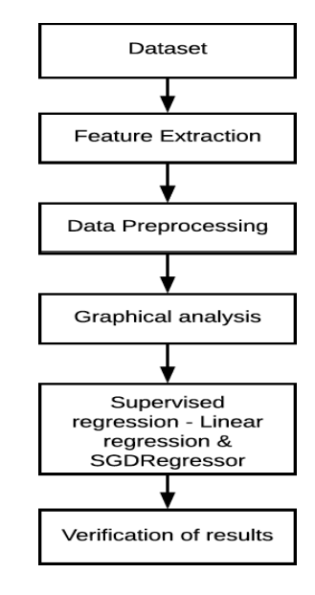

Figure 2: Training of data sets.

1. **METHODOLOGIES AND TOOLS USED**

**Data Collection:**

**Objective:** Gather a comprehensive dataset containing diamond features (Carat, Cut, Color, Clarity, Shape, etc.) and corresponding prices.

**Tools:** Web scraping tools (e.g., Beautiful

Soup, Scrapy), APIs from diamond marketplaces, CSV files from grading laboratories.

**Data Preprocessing:**

**Objective:** Clean and prepare the data for modeling by handling missing values, outliers, and converting categorical features.

**Steps:**

1. Data Cleaning: Remove or impute missing values.
2. Data Transformation: Normalize or scale numerical data, encode categorical data (e.g., using one-hot encoding).
3. Feature Engineering: Create new features or refine existing ones to improve model performance.

**Tools:** Python libraries (Pandas, NumPy, Scikit-learn).

**Exploratory Data Analysis (EDA):**

**Objective:** Understand the data distribution, relationships between variables, and identify patterns.

**Steps:**

1. Visualize data distribution and correlations.
2. Identify key features influencing the diamond prices.

**Tools:** Matplotlib, Seaborn, Plotly.

**Model Selection:**

**Objective:** Choose the appropriate machine learning model(s) for predicting diamond prices.

**Common Models:**

**Linear Regression:** Simple model to understand the linear relationship between features and price.

**Decision Trees/Random Forests:** For capturing non-linear relationships.

**Gradient Boosting Machines (GBMs):** For high accuracy through boosting.

**Neural Networks:** For complex, non-linear relationships.

**Tools:** Scikit-learn, XGBoost, TensorFlow, Keras.

**Model Training:**

**Objective:** Train the selected model on the training dataset to learn the relationship between diamond features and prices.

**Steps:**

* Split the dataset into training and testing sets.
* Train the model on the training set.

**Tools:** Scikit-learn, TensorFlow, Keras.

**Model Validation and Evaluation:**

**Objective:** Validate the model’s performance on the testing dataset and evaluate using relevant metrics.

**Steps:**

* Evaluate using metrics like Root Mean Squared Error (RMSE), Mean Absolute Error (MAE), R-squared.
* Perform cross-validation to ensure robustness.

**Tools:** Scikit-learn, Pandas.

**Model Optimization (Optional):**

**Objective:** Improve model performance by tuning hyperparameters or using more advanced techniques.

**Steps:**

* Hyper parameter tuning using Grid SearchCV or Randomized SearchCV.
* Experiment with different model architectures (for neural networks).

**Tools:** Scikit-learn, TensorFlow, Keras, Optuna.

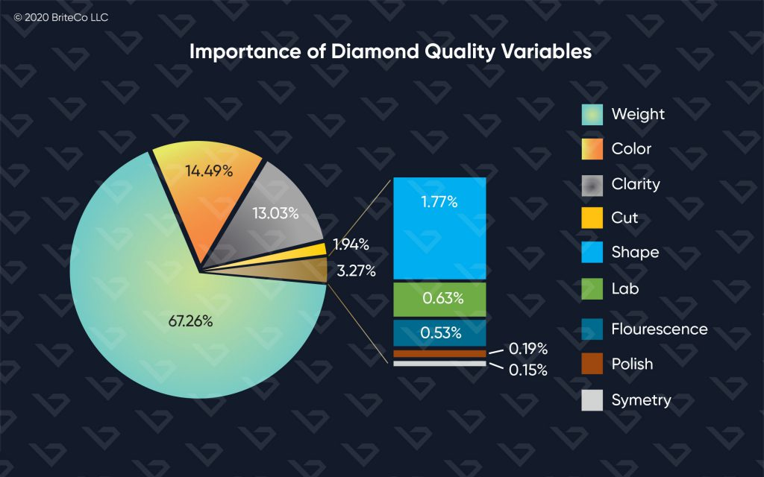

Figure 3: Importance of diamond quality variables.

**Prediction:**

**Objective:** Use the trained and validated model to predict prices for new diamonds.

**Tools:** Trained machine learning model, Scikit-learn, Pandas.

**Deployment:**

**Objective:** Deploy the model for real-time predictions in a production environment.

**Tools:**

* APIs: Flask, FastAPI for creating web services.
* Cloud Platforms: AWS, Google Cloud, Azure for deployment
* Docker: For containerizing the application.

**Monitoring and Updating:**

**Objective:** Continuously monitor model performance and update with new data to maintain accuracy.

**Tools:** Monitoring tools (e.g., Prometheus, Grafana), retraining pipelines (e.g., using MLFlow, TensorFlow Extended).

Tools Summary:

1. Data Handling: Pandas, NumPy.

2. Visualization: Matplotlib, Seaborn, Plotly.

3. Modeling: Scikit-learn, TensorFlow, Keras, XGBoost.

4. Model Evaluation: Scikit-learn, Cross-validation tools.

5. Deployment: Flask, FastAPI, Docker, Cloud Platforms (AWS, GCP, Azure).

6. Monitoring: Prometheus, Grafana, ML Flow.

**5. ADVANTAGES**

1. **Increased Pricing Accuracy:** Provides objective, data-driven price estimates, reducing human error.

2. **Efficiency:** Automates pricing, saves time, and can handle large inventories.

3. **Market Competitiveness:** Enables competitive pricing and quick adaptation to market trends.

4. **Better Investment Decisions:** Helps investors assess diamond value and reduce risks.

5. **Customer Empowerment:** Ensures transparency and helps consumers make informed purchasing decisions.

6. **Cost Savings:** Reduces appraisal costs and lowers operational expenses.

7. **Standardization:** Ensures consistent pricing across similar diamonds and industry benchmarking.

8. **Faster Time-to-Market:** Speeds up the pricing and market entry process.

9. **Enhanced Consumer Confidence:** Builds trust and educates consumers on fair pricing.

10. **Scalability and Adaptability:** Easily scales and updates with new data or market changes.

**APPLICATIONS**

1. **Market Analysis:** Helps investors and traders understand market trends, make informed investment decisions, and identify profitable opportunities.

2. **Inventory Management:** Assists jewelers and dealers in managing their inventory by predicting future prices, helping them decide when to buy or sell diamonds.

3. **Insurance Valuation:** Provides accurate valuations for insurance purposes, ensuring that diamonds are properly insured against loss or damage.

4. **Consumer Decision-Making:** Guides consumers in making informed purchases by predicting future price trends, potentially saving money on high-value purchases.

5. **Supply Chain Optimization:** Enhances efficiency in the diamond supply chain by predicting price fluctuations, which can impact sourcing and distribution strategies.

6. **Economic Research:** Contributes to broader economic studies by providing insights into the diamond market’s behavior and its impact on global economic conditions.

**6.REFERENCES AND RELATED RESEARCH PAPERS TO THE PROJECT**

REFERNCES:

1. Object Detection in Computer Vision

[**https://pluto-men.com/object-detection-in-computer- vision/#:~:text=Object%20detection%20works%20by%20using,the%20objects%20with%20bounding%20boxes**](https://pluto-men.com/object-detection-in-computer-%20%20%20%20%20%20%20%20%20%20%20%20vision/#:~:text=Object%20detection%20works%20by%20using,the%20objects%20with%20bounding%20boxes).

**2**. How to Fine-Tune YOLOv5 on Multiple GPUs

<https://towardsdatascience.com/how-to-finetune-yolov5-in-a-multi-gpu-environment-ada1935193d3>

3.Computer Vision: A Review of Detecting Objects in Videos – Challenges and Techniques

<https://www.researchgate.net/publication/358132310_Computer_Vision_A_Review_of_Detecting_Objects_in_Videos_-_Challenges_and_Techniques>

RESEARCH PAPERS RELATED TO THIS PROJECT:

1. Alsuraihi, Waad & Al-hazmi, Ekram & Bawazeer, Kholoud & Alghamdi, Hanan. (2020). Machine Learning Algorithms for Diamond Price Prediction. 150-154. 10.1145/3388818.3393715.

1. Mihir, H., Patel, M.I., Jani, S., & Gajjar, R. (2021). Diamond Price Prediction using Machine Learning. *2021 2nd International Conference on Communication, Computing and Industry 4.0 (C2I4)*, 1-5.
2. I. Marin and Z. A. Jabber, "Wireless Sensors Network based on Real-time Healthcare Monitoring," *2018 International Symposium on Fundamentals of Electrical Engineering (ISFEE)*, Bucharest, Romania, 2018, pp. 1-4, doi: 10.1109/ISFEE.2018.8742430.  
   keywords: {Medical services; Monitoring; Temperature sensors; Temperature measurement; Electrocardiography; Biomedical monitoring; biomedical monitoring; communication networks; health and safety; patient monitoring; sensors}
3. R. Chakrabarty, R. Karmakar, N. K. Das, S. Shivam and I. Mondal, "The Future of Real-Time Remote Monitoring: The Role of Low-Cost IoT Sensor Systems," 2023 7th International Conference on Electronics, Materials Engineering & Nano-Technology (IEMEN Tech), Kolkata, India, 2023, pp. 1-5, doi: 10.1109/IEMENTech60402.2023.10423554. keywords: {Market research; Sensor systems;

Real -time systems ; Reliability; Data communication ;Remote monitoring; Research and development; Low-cost IoT; Sensor Systems; Real-time Monitoring ;Remote Monitoring ;Sensor Reliability},